1. *Concatenate first and last name as full_name.*

*Answer:*

1. *Convert all employee names to lowercase.*

Answer:

1. *Extract first 3 letters of the employee's first name.*

1. *Replace '@company.com' in email with '@org.com'.*

1. *Trim spaces from a padded string.*

Answer:

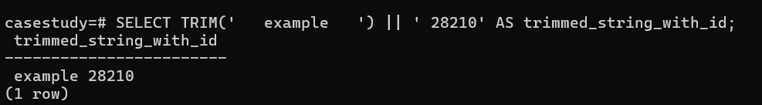

1. *Count characters in an employee’s full name.*

Answer:

1. *Find position of '@' in email using INSTR()/CHARINDEX().*

Answer:

1. *Add ‘Mr.’ or ‘Ms.’ before names based on gender (assume gender exists).*

Answer:

*9. Format project names to uppercase.*

*Answer:*

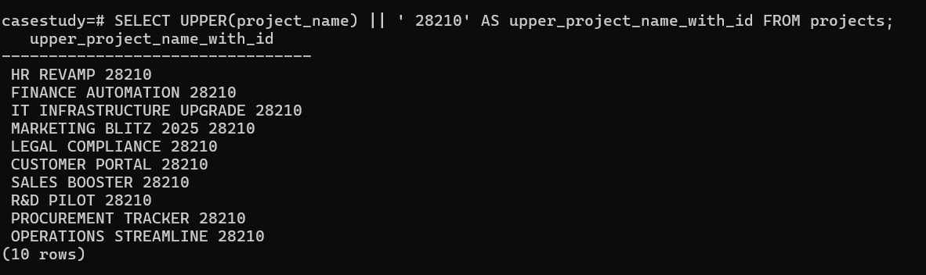

1. *Remove any dashes from project names.*

Answer:

1. *Create a label like “Emp: John Doe (HR)”.*

Answer:

1. *Check email length for each employee.*

Answer:

*13. Extract last name only from email (before @).*

*14. Format: “LASTNAME, Firstname” using UPPER and CONCAT.*

*Answer:*

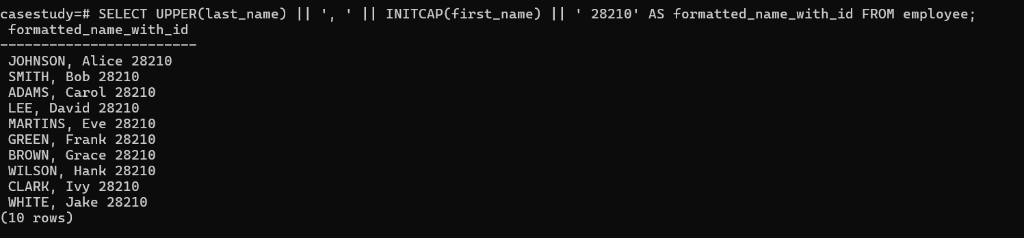

*15. Add “(Active)” next to employee names who have current projects.*

*Answer:*

*16. Round salary to the nearest whole number.*

Answer:

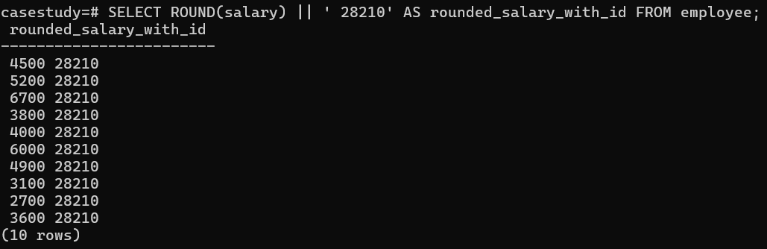

*17. Show only even salaries using MOD.*

*Answer:*

*18. Show difference between two project end/start dates using DATEDIFF.*

*Answer:*

*19. Show absolute difference in salaries between two employees.*

*Answer:*



*20. Raise salary by 10% using POWER.*

*Answer:*

*21. Generate a random number for testing IDs.*

*Answer:*

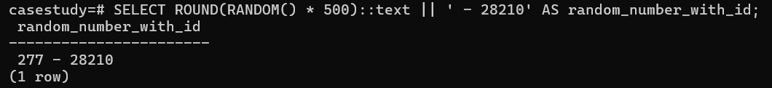

*22. Use CEIL and FLOOR on a floating salary.*

*Answer:*

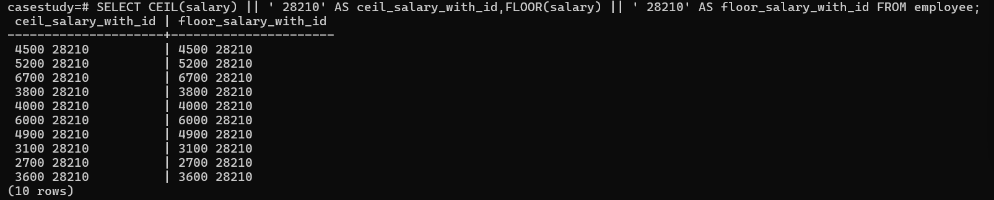

*23. Use LENGTH() on phone numbers (assume column exists).*

*Answer:*

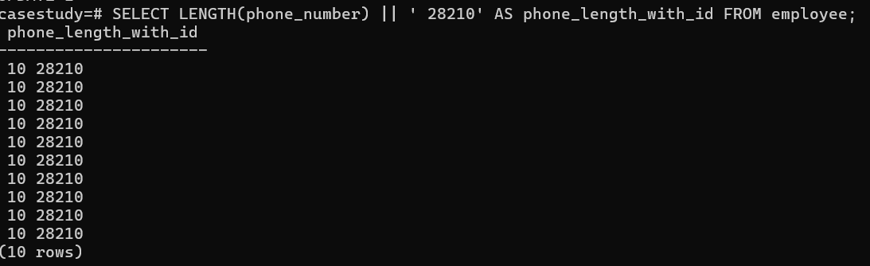

*24. Categorize salary: High/Medium/Low using CASE.*

*Answer:*

*25. Count digits in salary amount*

Answer:

*26. Show today’s date using CURRENT_DATE.*

*Answer:*

*27. Calculate how many days an employee has worked.*

*Answer:*

*28. Show employees hired in the current year.*

*Answer:*



*29. Display current date and time using NOW().*

*Answer:*

*30. Extract the year, month, and day from hire_date.*

*Answer:*

*31. Show employees hired before 2020.*

*Answer:*

*32. List projects that ended in the last 30 days.*

*Answer:*

**

*33. Calculate total days between project start and end dates.*

*Answer:*

*34. Format date: ‘2025-07-23’ to ‘July 23, 2025’ (use CONCAT).*

*Answer:*



*35. Add a CASE: if project still active (end_date IS NULL), show ‘Ongoing’.*

*Answer:*

*36. Use CASE to label salaries.*

*Answer:*

*37. Use COALESCE to show ‘No Email’ if email is NULL.*

*Answer:*

*38. CASE: If hire_date < 2015, mark as ‘Veteran’.*

*Answer:*

*39. If salary is NULL, default it to 3000 using COALESCE.*

*Answer:*

*40. CASE: Categorize departments (IT, HR, Other).*

*Answer:*

*41. CASE: If employee has no project, mark as ‘Unassigned’.*

*Answer:*

*42. CASE: Show tax band based on salary.*

*Answer:*

*43. Use nested CASE to label project duration.*

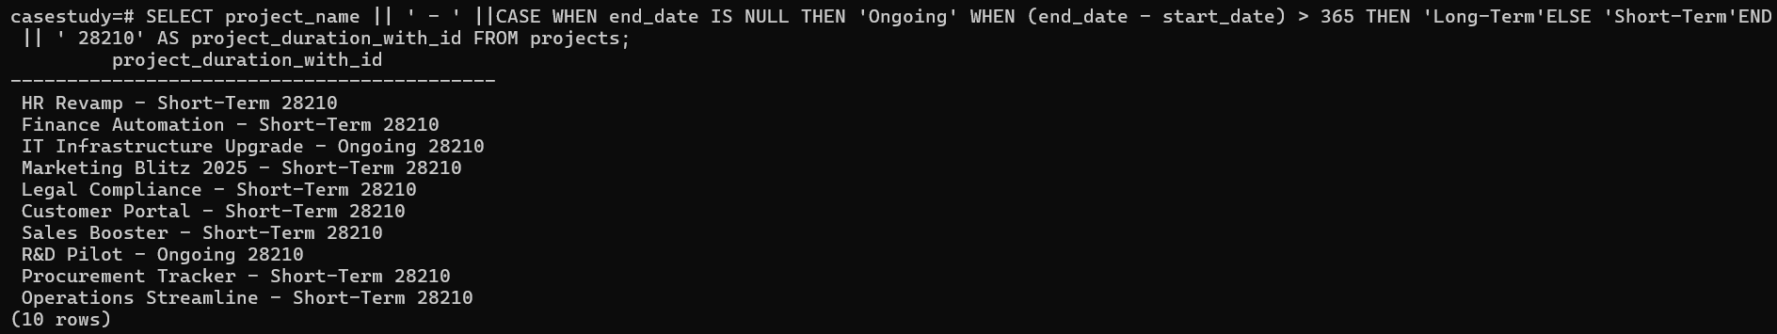

*44. Use CASE with MOD to show even/odd salary IDs.*

*Answer:*

*45. Combine COALESCE + CONCAT for fallback names.*

*Answer:*

*46. CASE with LENGTH(): if name length > 10, label “Long Name”.*

*Answer:*

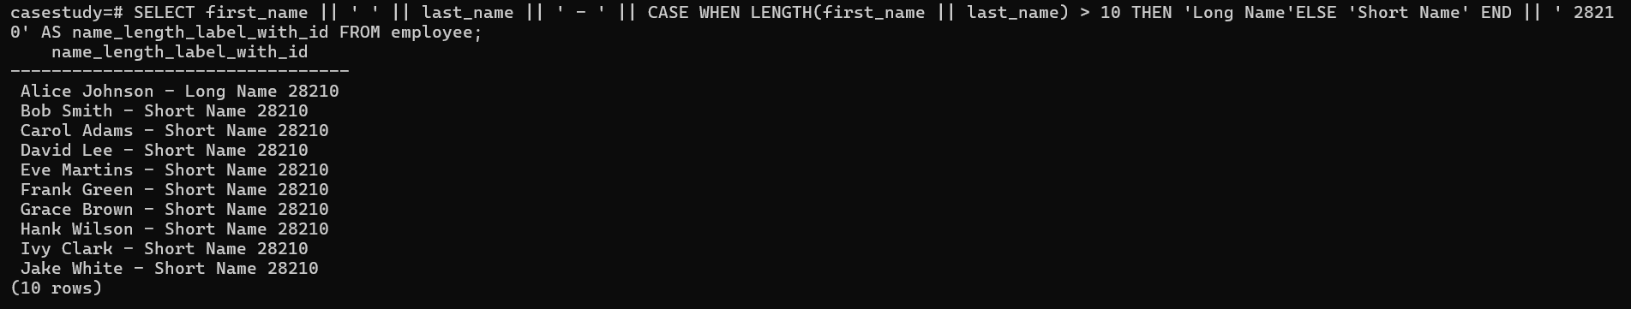

*47. CASE + UPPER(): if email has ‘TEST’, mark as dummy account.*

*Answer:*

*48. CASE: Show seniority based on hire year (e.g., Junior/Senior).*

*Answer:*

*49. Use CASE to determine salary increment range.*

*Answer:*

*50. Use CASE with CURDATE() to determine anniversary month.*

*Answer:*

